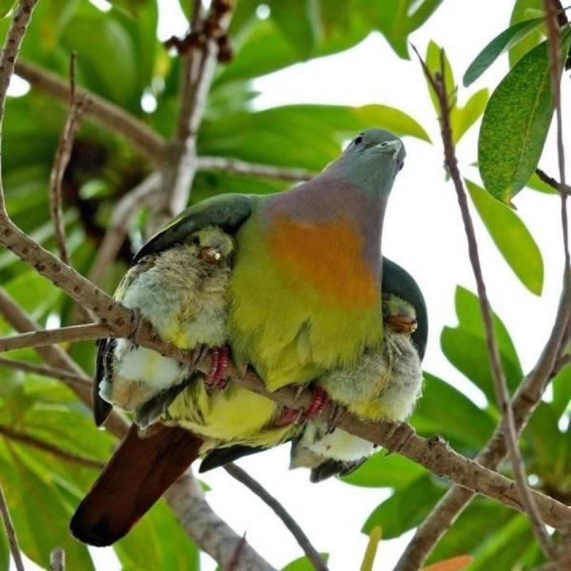
Meditations on the Psalms
A call to the Secret Place
Psalm 61
¹ Hear my cry, O God;
Attend to my prayer.
² From the end of the earth I will cry to You,
When my heart is overwhelmed;
Lead me to the rock that is higher than I.
³ For You have been a shelter for me,
A strong tower from the enemy.
⁴ I will abide in Your tabernacle forever;
I will trust in the shelter of Your wings. Selah
⁵ For You, O God, have heard my vows;
You have given me the heritage of those who fear Your name.
⁶ You will prolong the king’s life,
His years as many generations.
⁷ He shall abide before God forever.
Oh, prepare mercy and truth, which may preserve him!
⁸ So I will sing praise to Your name forever,
That I may daily perform my vows.

Don’t you just love that bird and the little ones? Can’t get away from it...the shelter, safety, security, protection...the mother is affording to the babies...

Read through the psalm slowly a couple of times and see what jumps out at you...

I see several words we have been thinking about...

- Shelter
- Wings
- Strong tower
- Abide
- Tabernacle
- Trust
And some new ones because this time it is a cry for help - the Psalmist’s heart is, in his own words, overwhelmed...
- Hear
- Attend
- Cry
- Lead
He knows where to go and Who to cry out to...

Maybe that is where you are right now – overwhelmed - if it is, let these words wash over you and comfort you -
Psalm 23:4
‘For You are with me;
Your rod and Your staff, they comfort me.’
You are with me...
Selah.
Psalm 119:50
‘⁵⁰ This is my comfort in my affliction,
For Your word has given me life.’
You will speak to me words of comfort...
Trouble, but God is our place of refuge.
One word from Him and we will be all right.
Selah.
Note the similarities to Psalm 91 – the Secret Place...
‘I will trust in the shelter of Your wings...’
Where else would we go?
There is such comfort in finding that others have had similar experiences, that we are not on our own in this, that God, aaah, He understands...
And nothing can come at us except He allows it – He allows in His wisdom what He could easily prevent by His power...
Selah.
So why is He allowing this?
Beloved, the ‘why’ question never gets an answer in this life.
A better question is ‘What does this mean?’
‘What should I do?’
Know He is with you in it.
When He said ‘Let us go to the other side of the lake’ He did not intend that you should drown in the middle of the lake...
He knew there was a storm brewing and that from His own internal peace, He would calm that storm -
‘My peace, I leave with you..My peace I give you.’ John 14:27.
Hey, beloved, peace is a -
G.I.F.T.
And He’s left it with you...
It’s your peace, He’s given it to you, it must be around here somewhere...you’ve just mislaid it, that’s all...
Selah.
And the psalmist is confident that God hears him.
Are you confident He hears you?
Well – are you?
Selah.
Hear David again in Psalm 27 -
‘³ Though an army may encamp against me,
My heart shall not fear;
Though war may rise against me,
In this I will be confident.’
What is the psalmist confident about?
‘The Lord is my light and my salvation;
Whom shall I fear?
The Lord is the strength of my life;’
Get your confidence – and your fear – in the right place.
Fear God, be confident in Him and you won’t worry about anything else...
Harness those two horses to your chariot of peace and see where it takes you!
Selah.
⁴ I will abide in Your tabernacle forever;
I will trust in the shelter of Your wings. Selah
Beryl M.

There is currently no copyright on this material please feel free to copy it in its entirety.
Visit www.psalm131.com for more free downloads.
Thank you.

