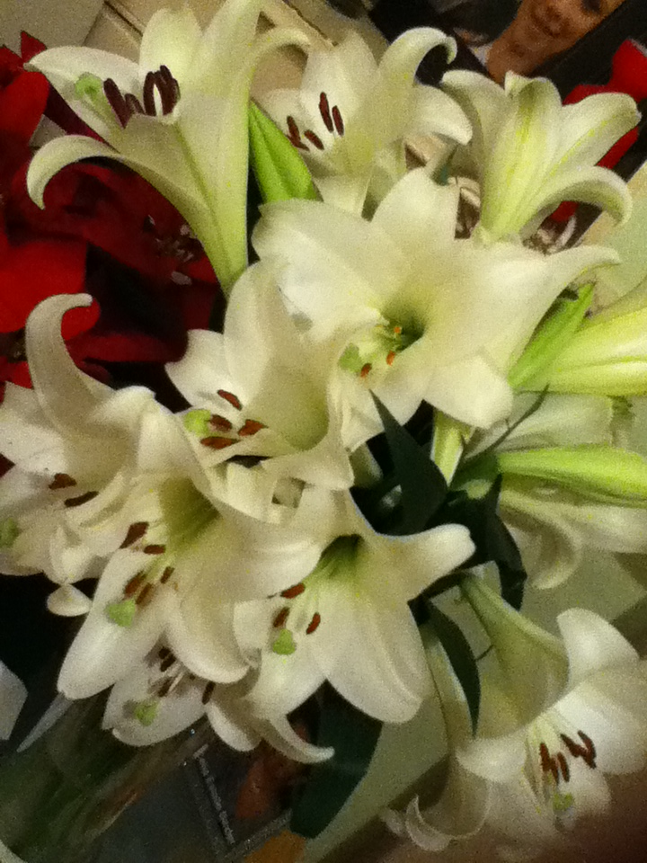

Meditations on the Psalms
A call to the Secret Place
Psalm 84 NIV(UK)

¹ How lovely is your dwelling-place, O LORD Almighty!
²My soul yearns, even faints, for the courts of the LORD; my heart and my flesh cry out for the living God.
³Even the sparrow has found a home, and the swallow a nest for herself, where she may have her young— a place near your altar, O LORD Almighty, my King and my God.
⁴ Blessed are those who dwell in your house; they are ever praising you.
⁵Blessed are those whose strength is in you, who have set their hearts on pilgrimage.
⁶ As they pass through the Valley of Baca, they make it a place of springs; the autumn rains also cover it with pools.
⁷ They go from strength to strength, till each appears before God in Zion.
⁸Hear my prayer, O LORD God Almighty; listen to me, O God of Jacob.
⁹ Look upon our shield, O God; look with favour on your anointed one.
¹⁰Better is one day in your courts than a thousand elsewhere; I would rather be a doorkeeper in the house of my God than dwell in the tents of the wicked.
¹¹ For the LORD God is a sun and shield; the LORD bestows favour and honour; no good thing does he withhold from those whose walk is blameless.
¹²O LORD Almighty, blessed is the man who trusts in you.

‘There’s a longing in My heart’, says the Lord, ‘that I seek to put in your heart My child...when you long to enter My courts, it is because the hunger in Me for you to come has begun to affect your heart – it is permission to come...your desire is My desire – come...’
The longing that is in His heart, is reflected in our hearts by the way we respond to Him...the way we seek after Him with all our heart, longing to be in His courts...desiring to walk with Him all the days of our lives...
When discipline and desire get married, they produce delight...
Selah.
But what if you have no desire...?
Then ask for it.
Ask for it.
Ask for a passion for Jesus and everything that He is...
Ask and keep on asking...
Until - you receive...
When you have the desire - discipline is a delight...and you discover -
God is a refuge; His heart is the home He has prepared for His children...
Selah.
The Psalmist likens this to a nest in a warm, safe place in the midst of God Himself...
³Even the sparrow has found a home, and the swallow a nest for herself, where she may have her young...
That must be a restful, peaceful, safe, place...
Selah.
His heart is your home...
His very heart is both your resting place and your dwelling place.
Your true home is not here...
And your true resting place is not made of bricks and mortar...
Selah.
Stress is an inside job...
We take it with us wherever we go...
And we are at best tenants, never owners here...strangers and aliens, passing through this world, we have a spiritual home –
‘The eternal God is your dwelling place and underneath are the everlasting arms’
Deuteronomy 33:27
Home is where the heart is...and when your heart is settled in Him, home can be anywhere; just so long as you are with Him...inside His heart...
Just where is your heart today?
Selah.
And we need never shout across an empty space to find Him – He is nearer than our next breath...
Peace, rest and wellbeing are all a matter of proximity, of closeness, nearness, intimacy -
He is near to those who call on Him...
Are you calling on Him this day?
Selah.
There is a dimension of rest in the heart of God that we have not yet thought of nor imagined...that we have not yet laid hold upon...yet there is permission –
To come...
To come into the Secret Place and abide there – forever.
What hinders you?
‘Your life is hidden with Christ in God’
Colossians 3:3

Hidden with Christ in God means you are in close proximity to, and in an intimate relationship with, both the Father and the Son...
Are you living near or in independence, afar off?
A father may say that his son seems to be getting closer to him as the years pass – he is not speaking in spatial terms, but in relationship terms – the things which held them apart over the years are dissolving and the father feels closer to the son who has been with him physically all through the years...but now is drawing closer - in relationship.
Like the father in the story of the Prodigal son, your heavenly Father watches for your return...daily watching at the gates to see the dust on the horizon kicked up by your feet as you race home...to your safe place, in Him.
There is no condemnation, why wait?
Return to the Lover of your soul -
Sandals, a robe and a ring await you...
Sandals - feet are about your destiny; a robe of righteousness and a ring are His covenantal promises...
Selah.
When Jesus stayed behind in the Temple, He grieved His earthly parents who did not understand that He had to be occupied with the business of His Father...
‘Whist ye not I had to be about My Father’s business?’
‘Didn’t you understand?’
He had to be there, He was compelled to be there, by an inner drawing...toward the altar in His Father’s house where even the sparrow has found a home...and the swallow can safely build her nest...picture language of course, but we understand what is being said – this, is a safe place – the only place -
¹ How lovely is your dwelling-place, O LORD Almighty!
²My soul yearns, even faints, for the courts of the LORD; my heart and my flesh cry out for the living God.

Worship is the natural outcome of dwelling in this place.

Our bodies are the present day Temple – the Temple of the Holy Spirit and worship is as natural as breathing...

Isn’t it?

Selah.

Our problem is believing that He really does want us there with Him.

Our biggest problem is believing that we really are His ‘peculiar’ treasure.

Unworthiness holds us back...or unbelief.

Unworthiness calls into question God’s motive for loving us...and it is the flip side of pride...a negative focus on ourselves...

Unworthiness or unbelief causes us to lose our way to His house...to our home, our resting place.

We will never find Him through our own efforts, only through the finished work of Jesus on the Cross.

‘Telios’ – paid in full, no debt outstanding, nothing more to pay, all done...we can do nothing but receive with gratitude...

A humbling position for someone who thinks their efforts will get them somewhere in the Kingdom...

Our only ‘work’ is to stay where He has put us...

‘O.K. Father.’
⁴ How blessed are those who dwell in Your house!
They are ever praising You.
Selah.
Selah indeed.
Beryl M.

There is currently no copyright on this material please feel free to copy it in its entirety.
Visit www.psalm131.com for more free downloads.
Oasis Community Trust is a Registered Charity Number 1029128.

