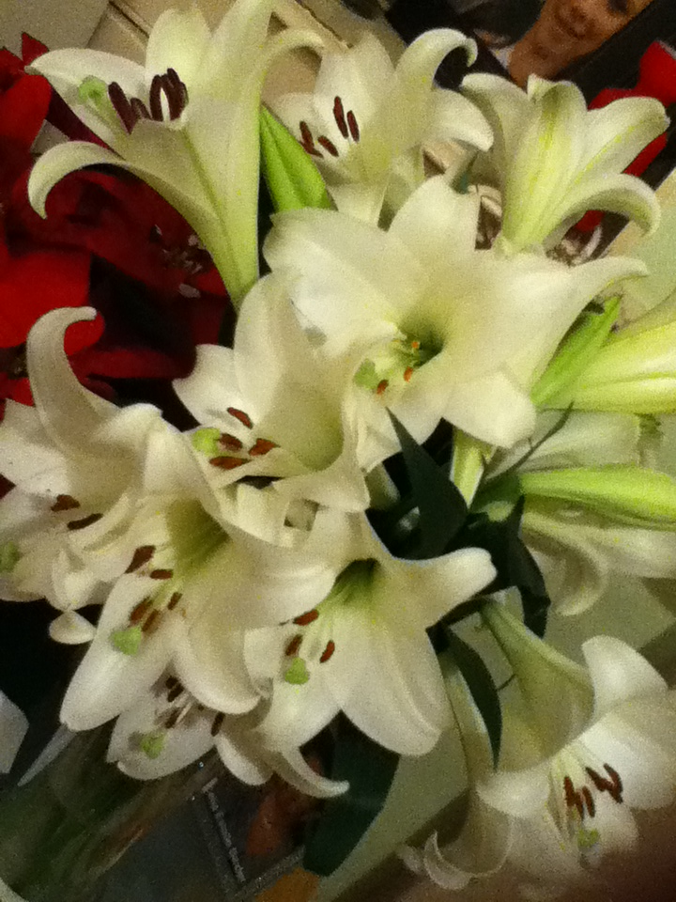
Meditations on the Psalms
A call to the Secret Place
Psalm 84
We are beholding the beauty of the Lord – the Lily of the Valley, the Rose of Bethlehem...His fragrance, His loveliness; all His garments carry ‘the fragrance of myrrh and cassia out of the ivory palaces’ (Psalm 45:8)...the purity of His love towards us, which seeks nothing but our highest good.

He never seeks to get something out of us, only put to put more of Himself into us...He is a ‘giving’ God...

‘Father, here we are, trusting, resting in You, we are so confident in You Lord, we want You to know that, we are so confident. We are asking that Your manifest Presence may come to us and touch us – cause us Father to lay down everything that is burdening us, everything that is bothering us, let it die Lord in Your Brilliance, Your manifest Presence...

We would place ourselves on your altar O God, giving our lives up to You in joyful expectation of transformation. We submit ourselves afresh to you, opening our hearts to Your touch, knowing we are the beloved of God on whom His favour rests...

We want to trade on that favour Father, first for ourselves and then for those around us, we want to come to the place of asking for and expecting the impossible because you are a God of limitless possibilities and nothing is impossible for You. Fill us afresh with Yourself, make our valley of Baca into pools of blessing...in Jesus name and for His sake.

Amen.
Psalm 84
Amplified Bible

¹HOW LOVELY are Your tabernacles, O Lord of hosts!
²My soul yearns, yes, even pines and is homesick for the courts of the Lord; my heart and my flesh cry out and sing for joy to the living God.
³Yes, the sparrow has found a house, and the swallow a nest for herself, where she may lay her young--even Your altars, O Lord of hosts, my King and my God.
⁴Blessed (happy, fortunate, to be envied) are those who dwell in Your house and Your presence; they will be singing Your praises all the day long. Selah [pause, and calmly think of that]!
⁵Blessed (happy, fortunate, to be envied) is the man whose strength is in You, in whose heart are the highways to Zion.
⁶Passing through the Valley of Weeping (Baca), they make it a place of springs; the early rain also fills [the pools] with blessings.
⁷They go from strength to strength [increasing in victorious power]; each of them appears before God in Zion.
⁸O Lord God of hosts, hear my prayer; give ear, O God of Jacob! Selah [pause, and calmly think of that]!
⁹Behold our shield [the king as Your agent], O God, and look upon the face of Your anointed!
¹⁰For a day in Your courts is better than a thousand [anywhere else]; I would rather be a doorkeeper and stand at the threshold in the house of my God than to dwell [at ease] in the tents of wickedness.
¹¹For the Lord God is a Sun and Shield; the Lord bestows [present] grace and favour and [future] glory (honour, splendour, and heavenly bliss)! No good thing will He withhold from those who walk uprightly.
¹²O Lord of hosts, blessed (happy, fortunate, to be envied) is the man who trusts in You [leaning and believing on You, committing all and confidently looking to You, and that without fear or misgiving]!
We are taking time-out to rest, dwell, remain, stay, in the Presence to contemplate, meditate, reflect upon, consider, think about - His heart towards us...His great heart of goodness and love.
We are meditating upon Him and His ways, we know we are going to receive something from Him because He cannot be other than true to Himself, He is a giver...
So slow down...
Stop trying to get somewhere – you are there already – the beloved, in the Beloved, placed there by God Himself.
Allow Him to touch you.
He initiates, we respond.
Our task is simply to remain where He has placed us – in the Christ.
So take a deep breath, lay it all down –
Again...
He is here.
He will touch you.
He will refresh you...
He will meet every need...
He is all you need.
The All Sufficient One, is enough...
Come to Him; wait on Him; wait for Him.
He is always worth waiting for...
Pause and think about that...‘He is always worth waiting for’ – don’t be afraid to repeat phrases which catch your attention...
Sink back into His everlasting arms – don’t forget He is holding the universe together – let your spirit man rise, let him dominate your rest, not your soul...
Don’t try to think your way into His Presence – let rest flow from the centre of your being.
He is your rest...
Selah.
Your soul always wants to be in control – allow the inner man to speak, put your soul under the benevolent control of the Holy Spirit.
You were created for Him, you are His Bride...
Yearning...my soul longs and yearns...
You are able to long for Him, because He longs and yearns for you – He loves every connection He has with you – ‘My great beauty...’
As you long and yearn for Him, where He is you long to be...you are reflecting what He is feeling for you...your heart longs for Him and His touch...His heart longs for intimacy with you...
He loves every connection He has with you...
He knows everything about you and He has set His love on you...
He will never change the way He feels about you.
He is the God of joy and laughter, His joy is perpetually full and overflowing – enter, into the joy of your Lord.
He is full of joy over you...
He rejoices over you with singing...(Zephaniah 3:17)
‘My great beauty’
Selah.
He is not disappointed in you...
He knew what He was getting when He got you.
His heart is full towards you.
Selah.
He is your strength – take Him now as strength for the day before you.
‘Father, I take You as my strength for this day and every day...’
I am a partaker of your holiness and righteousness -
‘Father, I receive Your holiness, Your righteousness Your wisdom...I receive You in Your fullness...’
Selah.
We cannot do anything or be anything unless He touches our heart; His nature, touching ours, transforming us into the image of His Son.
We cannot be good unless His goodness fills us.
Kindness and gentleness will elude us unless we are touched by these wonderful aspects of His nature...everything we are and have comes from Him.
‘My soul longs even yearns, for Your courts...my heart and flesh sing for joy to the living God’.
‘Without Me, you can do nothing.’
Selah.
Enjoy the bliss of having nothing, being nothing, except it comes from Him, enjoy being filled with His fullness, enjoy Him, revel in Him, rejoice in Him – He is your life.
Raise your arms now in child-like dependency, knowing He will lift you up.
Aaah the blessedness of possessing nothing, of being nothing, emptied, that He might be all.
¹²O Lord of hosts, blessed (happy, fortunate, to be envied) is the man who trusts in You [leaning and believing on You, committing all and confidently looking to You, and that without fear or misgiving]!
Selah.
Close your time of contemplation with a prayer of desire for Him -
‘Father, I pray that I will love You with all my heart today, that my mind will dwell in worship on You, that my will and emotions will bend towards adoration of Jesus; that my strength and energy of life will bless and glorify You, that every thought and word will give You pleasure, that every action of mine this day will make You smile - because Jesus deserves nothing less...
Amen.’

Beryl M.

There is currently no copyright on this material please feel free to copy it in its entirety.
Visit www.psalm131.com for more free downloads.
Thank you.
Oasis Community Trust is a Registered Charity Number 1029128.

