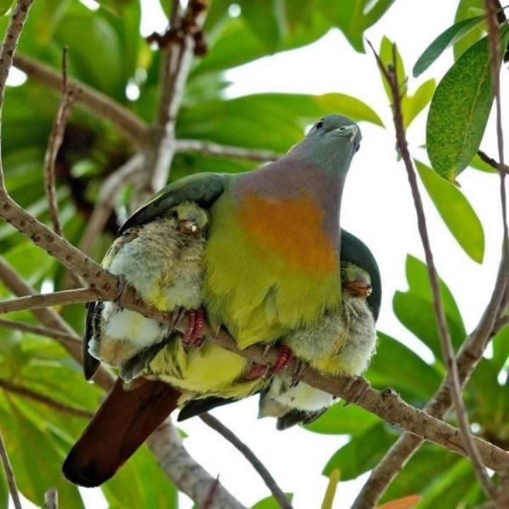

Meditations on the Psalms
A call to the Secret Place

Introduction:

My aim, in leading you through selected psalms, is to encourage you to enter the Throne Room to behold the beauty of the Lord; to encourage you to go deeper than you have ever gone before into the peace, the rest, the safety, the pleasure and the delight of a life lived in continuous connectedness with the Father, Son and Holy Spirit.

As our thoughts, perceptions and ideas, are replaced with His...as we deliberately focus on something bigger than ourselves...our problems shrink, or disappear completely as we enlarge our perception of Him and begin to comprehend the Majesty, Supremacy and greatness of our God and His all encompassing love for us; as we place Him between ourselves and the problem, we become incapable of worry beholding His Majesty in the Secret Place...and we are consumed with nothing else.

Meditation and contemplation is the devotional practice of setting aside time from everything and anything that would distract; it is deliberately turning our hearts towards Him and taking time to allow the words of a verse or verses of scripture to be ignited by the Holy Spirit and impact our hearts afresh.

Jeremiah put it like this –

Jeremiah 15:16 KJV

‘¹⁶Thy words were found, and I did eat them; and thy word was unto me the joy and rejoicing of mine heart: for I am called by thy name, O LORD God of hosts.’

Jeremiah took the very word of God into himself until it became ‘flesh’ upon him.

If you have never practised meditation or contemplation before, be easy on yourself, set yourself a goal that you know you will be able to keep to – maybe you will want start with just ten minutes a day and work from there.

Don’t be agitated if at first you find it difficult to concentrate and be at peace and at rest. He will wait, He has all the time in the world for you...He loves you and He loves every connection He has with you...

There is no place to get to, no hoops to jump through, no examinations to pass; He has already placed you in the one place where you can get all your needs met and all your prayers answered in Christ...all that remains is that you live, dwell and remain in Him - and get to know Him more and more...
‘Father, I come to you in the name of Your Son Jesus, I desire to know You better. Holy Spirit please teach me how to meditate on Your word, help me as I open my heart; please open the scriptures to me as I wait before You. In Jesus Name. Amen
When we come to this devotional time then, we do not come with a shopping list, but with a heart full of adoration because of what He has done for us, He has set us in a ‘high place’, we are higher than Adam and Eve at creation...we are seated in heavenly places.

So we slow down; we rest; we relax; we sink back into His everlasting arms, knowing He is in complete control of all things...

Selah! Pause and really and take this in...I will use this word; ‘selah’ to indicate that you need to stop and begin to digest what has been said throughout these meditations and contemplations; a notebook would be good to have at hand so you can write down, journal, what the Holy Spirit says to you...I found studying the picture above very profitable, in fact I keep coming back to it – this is us, tucked up under His wings – what a beautiful thought!

Feathers, feathers, feathers...soft, downy, secure, warm, safe, protected, defended – just look at the face of the bird...‘don’t touch my little ones or you will have me to contend with...’

What else can you sense or see? Write it down...

Then -

Read Psalm 91 in your own version or the version below out loud, very slowly, stopping if something grips your attention, repeating a phrase if it speaks to you – take your time –
PSALM 91
Amplified Bible

¹HE WHO dwells in the secret place of the Most High shall remain stable and fixed under the shadow of the Almighty [Whose power no foe can withstand].
²I will say of the Lord, He is my Refuge and my Fortress, my God; on Him I lean and rely, and in Him I [confidently] trust!
³For [then] He will deliver you from the snare of the fowler and from the deadly pestilence.
⁴[Then] He will cover you with His pinions, and under His wings shall you trust and find refuge; His truth and His faithfulness are a shield and a buckler.
⁵You shall not be afraid of the terror of the night, nor of the arrow (the evil plots and slanders of the wicked) that flies by day,
⁶Nor of the pestilence that stalks in darkness, nor of the destruction and sudden death that surprise and lay waste at noonday.
⁷A thousand may fall at your side, and ten thousand at your right hand, but it shall not come near you.
⁸Only a spectator shall you be [yourself inaccessible in the secret place of the Most High] as you witness the reward of the wicked.
⁹Because you have made the Lord your refuge, and the Most High your dwelling place,
¹⁰There shall no evil befall you, nor any plague or calamity come near your tent.
¹¹For He will give His angels [especial] charge over you to accompany and defend and preserve you in all your ways [of obedience and service].
¹²They shall bear you up on their hands, lest you dash your foot against a stone.
¹³You shall tread upon the lion and adder; the young lion and the serpent shall you trample underfoot.
¹⁴Because he has set his love upon Me, therefore will I deliver him; I will set him on high, because he knows and understands My name [has a personal knowledge of My mercy, love, and kindness--trusts and relies on Me, knowing I will never forsake him, no, never].
¹⁵He shall call upon Me, and I will answer him; I will be with him in trouble, I will deliver him and honour him.
¹⁶With long life will I satisfy him and show him My salvation.
-------- 0 --------
Begin to think about what you have just read, take your time...enjoy this you are on a journey with the Lover of your soul, slow down, stop, think deeply, rest, let Him touch you – He initiates, you respond...

When you are ready for some more, read on –

‘You are the beloved, in the Beloved’

What does that statement conjure up for you?

‘I am the beloved, in the Beloved’...

You, yes you, you are the beloved Bride, in the Beloved Bridegroom.

God the Father in His infinite love for you, has placed you, in the Christ; you are kept there by the power of God, the indwelling Holy Spirit; you are part of the community of heaven...your fellowship is with the Father and the Son...

How does that feel? Part of the Community of heaven...ummm

Part of the Community of heaven that existed from before the foundation of the earth, before anything was made...God planned a place for you...You have always been in His heart...

Your task is simply to –

- stay
- rest,
- remain,
- dwell

In that place...in the Beloved – Jesus.

What does it mean practically for you – to be ‘in Christ’?

Think about that for a little while...and journal your responses.

Thinking then about dwelling in that place...staying and remaining there...the mind of the Lord accessible to you at all times...wisdom, understanding counsel, all yours... ‘Son everything I have is yours’

Selah...Dwelling there as a permanent state

Think about resting in that place, far above all...kept by the power of God...

Let’s break those first couple of verses down a bit -
‘¹HE WHO dwells in the secret place of the Most High’...

What, for instance exactly is the ‘secret place’?

It is the heart of God Himself.

‘The Most High God’, though, what does that mean? The qualification ‘Most High’ tells us something else –

Hebrew - El Elyon, literally, the ‘Possessor of Heaven and earth’, the One Whom Melchizedek spoke of when he met Abram...(Genesis 14:18)

This ‘Most High God’, the Possessor of Heaven and Earth declares He wants to be my place of safety, He wants me to dwell in His very heart...

Selah!

‘...shall remain stable and fixed under the shadow of the Almighty [Whose power no foe can withstand].’

‘The Almighty’, bad translation that because it means - ‘the breasted One, the Nourisher...’ Hebrew - El Shaddai...the One who sustains all things, the provider...

The Father/Mother God, creator and sustainer of all things, the breasted One, the Nourisher...’

This All Mighty One is overshadowing you.

What would it be like under His feathers?

Think about that...

‘Thank You I am overshadowed by this All Mighty God,

²I will say of the Lord, He is my Refuge and my Fortress

‘Lord’ Hebrew - ‘YHWH’ which means the Self-Existent One...

The ‘I AM’ who spoke face to face with Moses, is your refuge, your fortress...your high tower...

‘Thank You, you are my refuge, my fortress’

What would a refuge and a fortress look like for you in the time of trouble? Somewhere to run to... and be kept safe and secure, protected and defended from everything...

The Lord, what a place! He is both my refuge and my fortress...somewhere to run to... in safety...
‘ my God; on Him I lean and rely, and in Him I [confidently] trust!
Wow, here we go again – ‘God’ Hebrew – ‘Elohim’, literally – ‘the Most Powerful of all the Powerful Ones...’

This gets better and we’ve only just started!

‘Thank You Father, here I am, safe and secure, kept by the power of God...’

I'm kept by such a great power...the implications of that could make me invincible...unconquerable, indomitable, as He is...

Selah.

The Self-Existent One; the Most Powerful God, the Possessor of Heaven and Earth, the awesome God, Who sustains and holds everything together hides me - in Himself...

Wow!

How can I worry when I am in this place?

Selah

‘Thank You Father, I dwell in the Secret Place of El Elyon, the Most High God, Possessor of Heaven and Earth...’

There are so many promises in this Psalm that are ours if we abide in that place...how can we not feel joy and thanksgiving rising within us...but maybe we are in a place of turmoil and it isn’t easy to take these promises for ourselves, that’s all right too, just love Him where you are at...

It makes you want to connect with Him in prayer again –

Father,
I thank You, thank You that You only, ever, work for my good. Lord, I want to thank you for what I am facing in my life right now, to be honest, I’m scared, but You have said You will teach me in and through this not to be afraid of anything; that there’s a place where I can come to where there’s nothing out there troubling me; because there is a place on the inside where I have a refuge a fortress, a high tower.
That would be a good place to be in Father, a place where I get my fear in the right place and only have a reverent awe and fear of You Lord.
I bless You Father, for this set of circumstances and all You plan to do in them. Thank You Lord, You are going to establish me in You in such a way that I know, that I know, that I know, that You are my place of safety...then my fear will be in the right place.
Be blessed, be glorified, be honoured, be praised this day in all I say and do. I choose right here, right now, to make You my fortress and my strong high tower.
Thank You Lord.
May Jesus Christ be praised.
Amen.

Beryl M.

There is currently no copyright on this material please feel free to copy it in its entirety.
Visit www.psalm131.com for more free downloads.
Thank you.

Oasis Community Trust is a Registered Charity Number 1029128.

