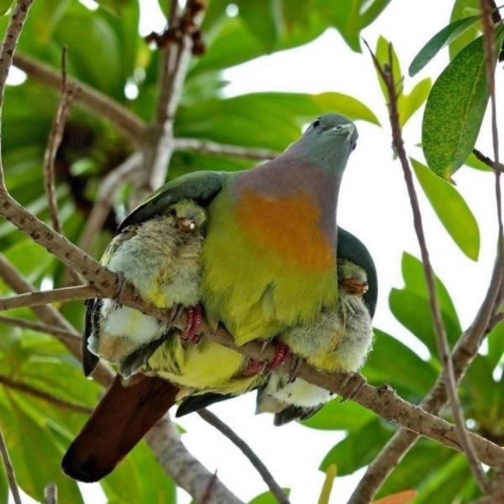

Meditations on the Psalms
A call to the Secret Place
PSALM 91
Part 2

We just can’t rush away from Psalm 91, there is so much more to be had here...

Read it out loud now in your own version...

The Secret Place – what a privilege, living inside the heart of this great God who loves us to distraction; so we become jealous to guard this time, being careful that our devotional time does not become our prayer time, our business relationship, but remains our intimate, personal time with our Bridegroom, where we pour out our alabaster box of love in devotion, adoration...and in the splendour of His manifest Presence we become occupied with Him - not ourselves.

In this place we learn to become conscious of Him – alone.

We develop dove’s eyes...

Song of Solomon 1: 14 – 16

Lover
¹⁵ How beautiful you are, my darling! Oh, how beautiful! Your eyes are doves.

A dove has no peripheral vision...

She is not distracted...

Her gaze is straight...
Looking only to Him...

Her Lover

In this place

We learn to run to Him...

Abide in Him.

Rest in Him.

He is our all sufficiency,

The All Sufficient One.

The Self Existent One.

‘I AM’.

Selah.

In days of trouble we can call on Him and He will either deliver us, or keep us in Himself as we go through the days in unbroken contact with Him...

We hide in Him...our hiding place, our refuge, our fortress, our shelter, our God...Who is for us, not against us...

We learn to live here in the secret place of His affection, the beloved, in the Beloved – at peace and at rest despite the storms which rage about us – He has promised to be with us.

We begin to develop the language of love, telling Him how much we love Him, declaring His goodness, faithfulness and love; proclaiming our confidence in what He is going to be for us...it’s the language of love between the Bridegroom and the bride...

The language of love and lovers...

‘The Bride eyes not her garment, but her dear Bridegroom’s face...’¹

Resting in the Secret Place we develop a single eye – looking only unto Jesus...because –

The I AM is with us.

He is here.

He is for us.

No matter how it feels...He’s here, He’s near; He’s for us, not against us.

Always.

Ever.

Only.

With the hymn writer² we can say –

‘How firm a foundation, ye saints of the Lord,
Is laid for your faith in His excellent word.
What more can He say to you than He hath said,
You who unto Jesus for refuge have fled?’

Fear not, He is with thee, O be not dismayed,
For He is thy God and will still give thee aid;
He’ll strengthen thee, help thee, and cause thee to stand
Upheld by His righteous, omnipotent hand.

In every condition, in sickness, in health
In poverty’s vale, or abounding in wealth;
At home and abroad, on the land, on the sea,
As thy days may demand, shall thy strength ever be.

When through deep waters He calls thee to go,
The rivers of grief shall not thee overflow;
For He will be with thee in trouble to bless,
And sanctify to thee thy deepest distress.

When through fiery trials thy pathway shall lie,
His grace all-sufficient shall be thy supply
The flame shall not hurt thee, His only design
Thy dross to consume and thy gold to refine.

The soul that on Jesus has leant for repose
He will not, He will not, desert to its foes;
That soul, though all hell should endeavour to shake
He’ll never, no never, no never, forsake.’

Selah.

Let’s settle it then, He will never forsake us, no matter how it ‘feels’; even in our darkest hour, or when we have been our silliest, He doesn’t condemn, He gently leads us – back to Himself.

‘And home rejoicing brought me...’

Little lost sheep; but not lost to Him, the omniscient One...the One who fills all things with Himself.

Omniscient, omnipresent, omnipotent – worth looking those words up and thinking about them sometime...

Selah. Pause and quietly think about those things...

Let your heart come to a place of rest and peace, He is in complete control...

‘Hey, I govern the universe and My burden is light, I am not anxious...’

Learning to lean, learning to leave, learning to cast, all our anxieties on Him...and leave them there: taking instead, His peace, His rest, His gentleness of spirit...don’t forget to take something ‘instead’ – the enemy loves a vacuum...

Nowhere to get to because we are already there, resting, trusting; He is the Vine, we are the branches...as we practice the Presence, living in Him, everything He is will be released inside us and will rise up from within us as rivers of living waters refreshing all who come into contact with us...

So we desire this place, we seek this place; we are not diverted from our quest to live here, in the Secret Place of God’s heart.

We have dove’s eyes – no peripheral vision.

Beloved, do not be distracted...from your journey into the heart of God for you...

Do not allow the busyness of life to prevent you dwelling, remaining, resting, abiding...

Be occupied daily with entering that place.

And the Holy Spirit will teach you to develop your inner man of the Spirit – He will refresh and renew you daily...

Peace restores you, makes you fresh, anxiety tires you, keeps you exhausted and lack-lustre...

Rest, is a weapon – against enemy attack...

Come then, to the Secret Place, the centre of God’s great heart of love for YOU – take refuge there now, your Hiding Place – where no-one and nothing can touch you.

‘Yourself inaccessible in the Secret Place of the Most High’ (verse 8 in the Amplified Version)...inaccessible, that would be nice...

Let His Spirit mingle with yours taking you up into new dimensions of rest and peace – into complete abandonment – in His Presence...

Let’s pray shall we –

‘Father, I bless You, You are so incredible Lord, just the way that you are in Yourself, You are so amazing...all the things that You ask us to be and do are everything that You are in Yourself and so it is a great joy and a privilege Lord, just to come and give ourselves, our hearts, afresh to You each day – to know that new every morning is the mercy of God, that you are so incredibly faithful Father. We pray Lord, a Spirit of wisdom and revelation in the knowledge of You will fall upon us this day, layering into us continuously foundational truths that are taking us down this road ever deeper into Your heart.

Help us Father to learn to rest, abide, stay and remain in the place where you have put us, in Jesus.

For Jesus sake and in His name’.

We aren’t finished with Psalm 91, I think we will come back to it again next time...

Beryl M.

^{1’}The sands of time’ a hymn by A R Cousin
²George Keith 1787.

December 2011

There is currently no copyright on this material please feel free to copy it in its entirety.
Visit www.psalm131.com for more free downloads.
Thank you.

