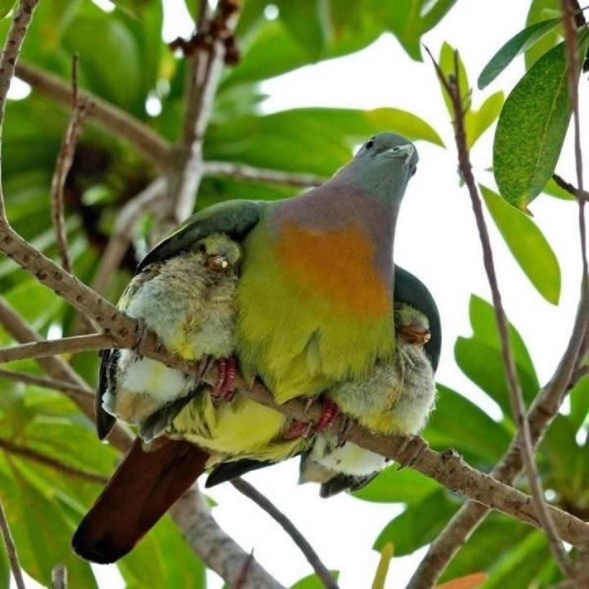
Meditations on the Psalms
A call to the Secret Place
PSALM 91
Part 4
(New International Readers Version)
The person who rests in the shadow of the Most High God
will be kept safe by the Mighty One.
² I will say about the Lord,
"He is my place of safety.
He is like a fort to me.
He is my God. I trust in him."
³ He will certainly save you from hidden traps
and from deadly sickness.
⁴ He will cover you with his wings.
Under the feathers of his wings you will find safety.
He is faithful. He will keep you safe like a shield or a tower.
⁵ You won't have to be afraid of the terrors that come during the night.
You won't have to fear the arrows that come at you during the day.
⁶ You won't have to be afraid of the sickness that attacks in the darkness.
You won't have to fear the plague that destroys at noon.
⁷ A thousand may fall dead at your side.
Ten thousand may fall near your right hand.
But no harm will come to you.
⁸ You will see with your own eyes
how God punishes sinful people.
⁹ The Lord is the one who keeps you safe.
So let the Most High God be like a home to you.
¹⁰ Then no harm will come to you.
No terrible plague will come near your tent.
¹¹ The Lord will command his angels
to take good care of you.
¹² They will lift you up in their hands.
Then you won't trip over a stone.
¹³ You will walk all over lions and cobras.
You will crush mighty lions and poisonous snakes.
¹⁴ The Lord says, "I will save the one who loves me.
I will keep him safe, because he trusts in me.
¹⁵ He will call out to me, and I will answer him.
I will be with him in times of trouble.
I will save him and honour him.
¹⁶ I will give him a long and full life.
I will save him."

There’s actually plenty of flak coming towards the writer of this psalm...traps, sickness, terrors, plagues, death, lions, snakes, trouble...BUT
The person who rests in the shadow of the Most High God will be kept safe by the Mighty One.
What a wonderful promise...KEPT.
In a place of safety when all this is happening...
Worlds are colliding, everything is falling apart, the money market is collapsing - looking at the circumstances....BUT we will be kept...
The person who rests in the shadow of the Most High God will be kept safe by the Mighty One.
He who rests in the shadow...will find a secret place.
Just how restful are you right now?
On a scale of 1 to 5, 5 being very peaceful and restful...
Come on now, be honest!
We can all be peaceful and restful when there’s nothing out there bothering us...the key is to be restful in the midst of the battle...in the midst of sickness, shortage...
REST.
Selah.
Rest is a weapon against our circumstances and the enemy.
And we are in a battle every day of our lives whether we like it or not.
Mostly it’s a battle within to keep calm when everything outside is falling apart.
Cultivating rest and peace in every situation is our life’s work.
Stress is an inside job...
Others don’t stress you – you do, by the way you react...
Nobody makes you angry – you chose to be angry...you made a choice beloved...
Selah.
Troubles and trials will come, we can’t escape them, Psalm 91 isn’t a vaccination against trouble, but a promise that we will be kept, in it and through it, and it isn’t so much the tests, trials and troubles as the way we approach them and go through them...life happens...
And God allows in His wisdom what He could easily prevent by His power.
Consider this story -
“On September 5, 1861, in Chicago, Horatio Spafford married Anna Larsen, of Stavanger, Norway. The Spafford’s were well-known in 1860's Chicago. Horatio was a prominent lawyer and he and his wife were also prominent supporters and close friends of evangelist Dwight L. Moody.
Spafford had invested heavily in the city's real estate; the Great Chicago Fire which swept through the city in 1871 destroyed almost everything Spafford owned.
In 1873, Spafford decided his family should take a holiday somewhere in Europe, and chose England knowing that his friend D. L. Moody would be preaching there in the fall. He was delayed because of business, so he sent his family ahead: his wife and their four children, daughters - eleven year old Anna “Annie”, nine year old Margaret Lee, five year old Elizabeth “Bessie”, and two year old Tanetta.
On November 22, 1873, while crossing the Atlantic on the steamship Ville du Havre, their ship was struck by an iron sailing vessel and two hundred and twenty-six people lost their lives, including all four of Spafford's daughters only Anna Spafford survived the tragedy. Upon arriving in England, she sent a telegram to Spafford beginning "Saved alone." Spafford then sailed to England, going over the location of his daughters' deaths. According to Bertha Spafford Vester, a daughter born after the tragedy, Spafford wrote this hymn "It Is Well With My Soul"¹ on this journey.”
‘When peace, like a river attendeth my way,
When sorrows like sea billows roll,
Whatever my lot, Thou has taught me to say,
‘It is well, it is well, with my soul’.’

‘Whatever my lot’ – loss of material things in a fire, loss of those most cherished by drowning...

This man was learning something through these tragedies – you don’t hear him crying ‘Why me, why, God, why?’ Though he would have had every reason to ask...His default setting was God Himself and His comfort in the day of trouble.
We all have a default setting – Horatio Spafford’s was clear.
What’s yours?
Just stop right there and have a little think...
What does your heart default to?
Selah.
‘It is well, it is well, with my soul’.
Trusting, resting?
Childlike faith?
Fretful, fearful, angry, resentful, why me?
When trouble hits.
Where is your first port of call?
The Throne?
The ‘phone?
Selah.
‘When through deep waters He calls thee to go,
The rivers of grief shall not thee overflow;
For He will be with thee in trouble to bless,
And sanctify to thee thy deepest distress.

When through fiery trials thy pathway shall lie,
His grace all-sufficient shall be thy supply
The flame shall not hurt thee, His only design
Thy dross to consume and thy gold to refine.

The soul that on Jesus has leant for repose
He will not, He will not, desert to its foes;
That soul, though all hell should endeavour to shake
He’ll never, no never, no never, forsake.’²

Selah.

Distress.
These old hymn writers knew it.
We can’t fortify ourselves against trouble beloved of God, no good bracing ourselves, it just comes, unbidden...when we least expect it...
What we can do, is develop our internal compass, our internal frame of reference, so that in that day of trouble, we are set, fixed, steadfast, on our magnetic north – Jesus.
We might swing about a bit at first, but we settle...kept, safe, in the Secret Place...
‘Though Satan should buffet, if trials should come
Let this blest assurance control,
That Christ hath regarded my helpless estate
And hath shed His own blood for my soul...’¹
‘Helpless estate’ equals total dependency; childlike trust; ‘neither know we what to do but our eyes are on You...’ 2 Chronicles 20: 1 – 30.
He has undertaken to keep you – in all your ways...
To keep your foot from being moved...
Think about it -
Absolutely, certainly, He will...keep you...no matter what...He has covenanted to keep you - He is a covenant maker and a covenant keeper...
Read Psalm 121 and John 17: 7 – 23.
Selah.
Anchored, steadfast, whilst the sea billows roll...
God’s keeping power whilst we rest, holding our course in the storm...
‘But Lord, ‘tis for Thee, for Thy coming we wait.
The sky, not the grave, is our goal;
Oh, the trump of the angel! Oh voice of the Lord!
Blessed hope! Blessed rest, of my soul’ ¹
Beryl M.
¹Wikipedia entry on the life of Horatio Spafford – ‘When peace like a river...’
² ‘How firm a foundation’ George Keith 1787.

There is currently no copyright on this material please feel free to copy it in its entirety.
Visit www.psalm131.com for more free downloads.
Thank you.

