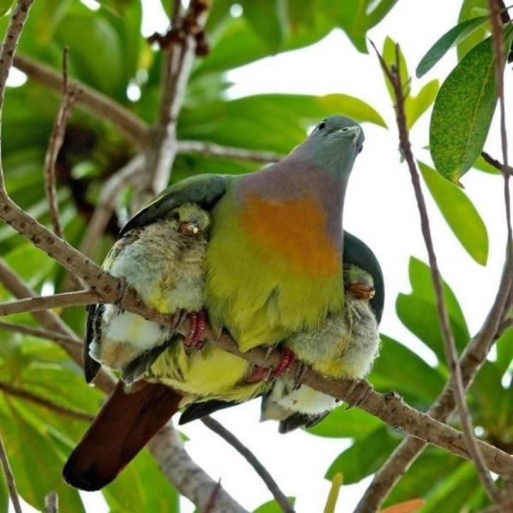
Meditations on the Psalms
A call to the Secret Place
PSALM 91 NASB
Part 5

Security of the One Who Trusts in the LORD.
¹ He who dwells in the shelter of the Most High
Will abide in the shadow of the Almighty.
² I will say to the LORD, “My refuge and my fortress,
My God, in whom I trust!”

Read through these verses slowly a couple of times and see what jumps out at you...
God has an agenda here – He is seeking to get us to live from a completely different place; He is seeking to get us to live from a high place, from our spirit man, not our soul, our ‘natural’ man...and He is seeking –
R e l a t i o n s h i p
That’s what He’s always after.
Your heart -
‘I have captivated your heart, and now I seek to captivate – you...’
If you want to know His dream for you – I can tell you – it is ‘you and Me – together’.
He is the Bridegroom, you are the bride and...
He wants you to live in a place of refuge and safety, enfolded in the Majesty of His love; no matter what is happening on the outside; He wants you to understand you don’t take your information from the world, but from Him...
You are in the world, but not of it...
A race of people never before seen on the earth – a race of people who are indwelt by God Himself...
Luke 17: 20 – 21 NKJV
²⁰ Now when He was asked by the Pharisees when the kingdom of God would come, He answered them and said, “The kingdom of God does not come with observation; ²¹ nor will they say, ‘See here!’ or ‘See there!’ For indeed, the kingdom of God is within you.”
God Himself, lives within – you...
Selah.
And the Holy Spirit is teaching us to live from this place; we are to learning step back into the Secret Place of His heart; we are learning to practice this at every opportunity – and we find we have plenty of those – until it becomes second nature to us to retire into our refuge and our fortress in God whom we trust...
T. R. U. S. T.
Trust and faith are relational issues.
It’s about knowing, really knowing, the One who alone is trustworthy...
Trust is simply making Him the first place we go...
Because we have proved Him to be faithful and trustworthy...
You do trust Him don’t you?
Try this ‘litmus test’ prayer -
Father,
I thank You that I can put all that I am, all I have, and all I hope to become - all my dreams for the future - into Your hands. I can live a life of celebration, knowing that You are powerful, faithful and wonderful on my behalf...I want Your plans and purposes, not just my own; take mine and correct them, change them so that my life is aligned with Your desires - I place mine into Your hands...’
Just how easy - or difficult is it or would it be for you to say that to Him without reserve?
‘I trust You, I give everything I hold dear into Your hands...into Your safe keeping knowing You are faithful, powerful and wonderful on my behalf.’
If you aren’t in a position to pray that prayer and mean it, don’t fret, maybe it is time for you to have a ‘selah’ moment.
Time to stop and think why you cannot let everything go into His hands, what secret fears are lurking there about His nature towards you - no condemnation – God doesn’t do judgement, shame or blame...just allow yourself to be absolutely honest...with yourself.
‘Why am I afraid?’
‘What makes me insecure in Your love?’
His love perfected in you will cast out fear...
Selah.
This is the journey we are all on, being perfected, matured, in the knowledge of Who He really is and His love for us...
When the enemy accuses you of not trusting; God has a plan. All things work together for good beloved - that plan is encouragement and blessing, placed right there, next to every accusation Satan makes...
He uses the enemy’s accusations against you to highlight the part of your life He plans to kiss next – wherever Satan incriminates you, God will bless you...
How brilliant is that!
‘I allow the evil one to point out the very place where I plan to help you triumph next! How marvellous of Me!’¹
What a beautiful thought...
God is confident in His own ability to turn everything, no matter how dire or difficult, into a blessing.
What difficulty do you need turned into a blessing right now?
Selah.
And what is your internal frame of reference?
By that I mean do you look outside yourself for God when He is inside – the Kingdom is within you...
We are a race of people never before seen on the earth...
A people indwelt by God Himself...
Sometimes we lose sight of the magnitude of the Gospel.
Sometimes we lose sight of the magnificence of the Gospel...
And we look outside ourselves for something in which to place our trust...
We look for the next meeting or the next conference...
Or we rely on something other than Him to come through for us...
- Our abilities
- Our money
- Our plans
- Our friends
- Our counsellors
Nothing wrong with these, just as long as they aren’t your first point of reference...so long as they aren’t where you are putting your -
T.R.U.S.T.
Because He wants to be your place of refuge, your all sufficiency, the place where you go –
F. I.R. S. T.
If you have never considered the thought, that He is inside your heart, just a breath away, I suggest you stop right there and think about it...
‘Do I seek without that which is within?’
Selah.
What we are doing here is raising our God-consciousness, our awareness of His constant and consistent Presence with us...His desire for our company, for us as His people, His desire that we know Him...and the Majesty of His love...His desire to be all we need...El Shaddai, the breasted One, the nurturer, the sustainer of all things -
‘Never will I leave you; never will I forsake you.’ Hebrews 13:5
That’s pretty certain then – that’s a promise to keep us going...
The soul that on Jesus has leant for repose
He will not, He will not, desert to its foes;
That soul, though all hell should endeavour to shake
He’ll never, no never, no never, forsake.’²

He loves us with a passion that is embarrassing...for Him; it is Valentine’s Day every day!

If you don’t believe me, just stop right there and ask Him.

God is a romantic.

And He loves passionately.

You are the object of His passion.

God comes to dwell in our hearts and He makes it His kingdom as we yield inwardly to Him...
We bring everything under His control and turn inwardly to that place of stillness to meet with Him there...
Getting to that place is a process...
No condemnation about where we are right now, God doesn’t do judgement but consider...
What changes in your thinking might you need to make to believe that He is unceasingly magnificent on your behalf?
Unceasingly magnificent - towards you?
Everything is ‘yes’ and ‘amen’ in Jesus...
What changes would you need to make in the way you think to enable Him to be what He wants to be for you right now?
Make a list.
Selah.
That is what we mean by having an internal compass, having an internal frame of reference; a place to which we default...Him.
Meeting Him in the Secret Place.
Abiding.
Under.
His control.
Listening.
Watching.
Waiting.
Loving...
Developing our rest and peace, confidence and expectation in His faithfulness and keeping power – simply trusting...
Selah.
Faith isn’t difficult beloved, it’s knowing Someone Who is faithful...
Someone Who never, ever, changes the way He feels about you...
Whose thoughts are unceasingly magnificent towards you...
Who never sees your failings, only your possibilities...
Who always calls you up to be something better, bigger, higher than you think you can possibly attain...with Him the possibilities are – limitless –
Selah.
³Limitless possibilities -
‘I saw only fences...You opened gates.
I said "I can't..."You said, "I know...”
I drowned in my smallness -You overwhelmed me with Your bigness.
When I couldn't imagine a future,
You whispered and kissed and sang Your song to me until I simply had to follow,
Until I found myself standing before a door... knocking.
And somewhere in the knocking, in the waiting,
I began to dream of a life beyond the door...and
At some point, in the knocking while I waited -
You stole my fears - and placed hope in my pocket.

So I stopped crying about endings and began looking for the beginning.
Until the door vanished, when I least expected,
And I tumbled into a space so wide, so vast, so blue, so ...You,
Where there are no ceilings, no walls, not even a floor to restrain me...
A landscape without limits...
Endless plains of hope...
Rivers of renewal...
Everest’s of imagination...
Summits, still in clouds, begging to be climbed...
I am surrounded here by runners, climbers, dreamers -
Explorers who live in the question -
"What's out there?"
Adventurers without maps,
Who navigate with compasses set on True North...
So I stand still, listening... resting...

And You are smiling at my wonder...
Delighting at my discovery of who You really are...
And who I really am -
Until I gather myself,
And begin...to run... and run... and run...
And climb and climb and climb...
For You are the summit...
You are the peak...
Living with You in Your ‘Secret Place’...
The possibilities are - limitless...
And I have found my heart’s desire –
In You.’
I sense His Presence upon you...

Beryl M.

¹ Graham Cooke ‘Clothed in His Presence’
²‘How firm a foundation’ George Keith 1787.
³ ‘Limitless Possibilities’ author unknown

There is currently no copyright on this material please feel free to copy it in its entirety.
Visit www.psalm131.com for more free downloads.
Thank you.

