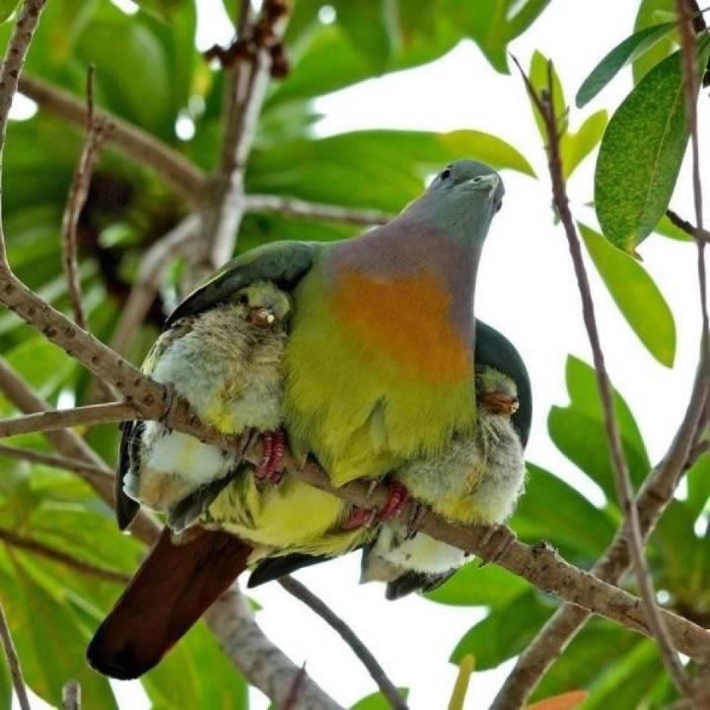
Meditations on the Psalms
A call to the Secret Place
PSALM 91
Part 6

We are called to live in the Secret Place of God’s own heart...
In that place He will shelter us from the attacks of the enemy, only allowing in His wisdom what He could easily prevent by His power...
Selah.

In the Secret Place He will comfort and strengthen us with His kindness and grace...

Nothing can come against us unless He allows it, and if He is allowing it, then it will turn to our gain, our profit, our increase...

He is good.

Selah.

Read the psalm again in your own version.

There are no good days, no bad days in the Kingdom, only days of grace...
Majestic, abundant, grace and endless possibilities which we can see from our place of safety, inside His great heart of love for us...
No matter what -
No matter what...
He is faithful, He never changes the way He feels about you.
When He looks upon You He sees something He can love.
When He looks upon you, He does so with pleasure.
He doesn’t see your faults or failings, He knows He can kiss those away, He sees something He can love...and whose possibilities in this life are limitless...
Your part is to -
Sit, stay, remain, abide

It’s a discipline...
Sitting still...
Staying.
Remaining.
Abiding.
How are you making out with it?
How is it working out for you?
Selah.
In days of trouble, we call upon Jesus and He will either deliver us from the situation, or keep us in Him as He walks with us through it...
He will be our refuge, our hiding place, our very real place of shelter...
So we must learn to live from this place.
We must learn to run into Him.
Learn to turn inwardly to the inner man of the Spirit – because the Kingdom is within us...
Selah.
It’s a labour Hebrews 4 will tell you, it’s hard work – we labour to enter into this place of rest – sounds like a contradiction...but then the word of God often does seem to be a paradox, but when you look deeper, you find that it isn’t at all...
Sitting, staying and remaining will require – e f f o r t – because everything will militate against it.
Demands.
People.
Problems.
Situations.
Circumstances.
But God.
He’s ENOUGH.
All sufficient.
ALL.
Means.
All.
Selah.
‘Abiding’ in the one place where you can get all your needs met and all your prayers answered...
And the Holy Spirit loves to teach you.
He loves you and He loves His job which is to keep you in that place, that Secret Place of God’s own huge heart of love for you...
Teaching you to regain your inner territory and maintain your own inner compass.
Persistence pays.
Stick with the programme and you will succeed in bringing yourself to a place of rest in Him...
“My refuge and my fortress,
My God, in whom I trust!”
Stating the obvious, you can’t trust someone you don’t know...

So let’s start this time by asking a question –

Just how well do you know Him?

Not a trick question, but it has to be answered honestly or we can’t go any further.

He wants you to know Him.

It is His desire that you know Him

‘Know Me, I want you to know Me; know Me; Who I really, really am – for you.’

Up front and personal!

How about making a list of how you know Him – that which is personal to you – that which you have experienced – not head knowledge, experiential...

‘A man with an experience’ after all ‘is beyond reason.’

Do you know Him as –

Bridegroom

Father

Shepherd

King

Husband

Lover

Deliverer

Fortress

Rock

Friend

Supporter

Vindicator

Strength

Other?

Have you known –

His kindness

His stability

His grace

His immutability (His unchanging nature towards you)

His compassion

His forgiveness

His mercy

His help, ooooh His help...

His goodness

His love...

Can you witness to some of these personally?

Happy is he who has the God of Jacob for his help...

‘⁵Happy (blessed, fortunate, enviable) is he who has the God of Jacob for his help, whose hope is in the Lord his God’
Psalm 146:5

You might be surprised at how well you do know Him as you do a review of His faithfulness towards you over the weeks, months, years...

Selah.

And all the promises in this psalm are for those who do what it says -
...abide in the shadow of the Almighty.
All you want for all you need, in Him.
If we abide in Christ, learn to live from our Spirit man that is born again from above and forever linked to Jesus, then God will live in us. ‘I AM’ is present with us now – we must learn therefore to rest, dwell and remain in Him...
No Rambo’s here, no self made men (or women) here...just utter dependency on the goodness, the kindness, the mercy, the faithfulness, the steadfast love of God Himself...
So be preoccupied with entering that place every day - learn to develop your inner man of the spirit, your internal hiding place, with the help and encouragement of your teacher, encourager and helper – the Holy Spirit...
It is His goal to promote the inner man; the inner life of the spirit over the soul; He will help you...He will comfort and strengthen you...
Be involved with Him, be conscious of Him, He is God the Father’s gift to you...you can’t do this on your own, you must enlist His help – why not stop and do that right now?
‘Holy Spirit, I need You, I can’t reach the depths and the heights I need to reach in God without You, please make Yourself real to me.’
Selah.
Come then, into the Secret Place, the very centre of God’s great heart of love for you and know Him as your refuge, your fortress, your hiding place, your dwelling place, your place of safety and security...
Be preoccupied with entering that place daily - make it a habit...
Selah.
Beryl M.

There is currently no copyright on this material please feel free to copy it in its entirety.
Visit www.psalm131.com for more free downloads.
Thank you.

