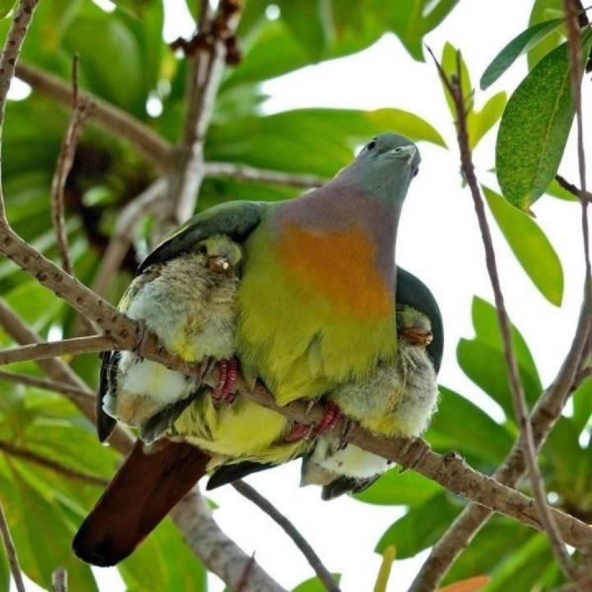
Meditations on the Psalms
A call to the Secret Place
PSALM 91 NKJV
Part 7
He who dwells in the secret place of the Most High
Shall abide under the shadow of the Almighty.
² I will say of the Lord, “He is my refuge and my fortress;
My God, in Him I will trust.”
³ Surely He shall deliver you from the snare of the fowler
And from the perilous pestilence.
⁴ He shall cover you with His feathers,
And under His wings you shall take refuge;
His truth shall be your shield and buckler.
⁵ You shall not be afraid of the terror by night,
Nor of the arrow that flies by day,
⁶ Nor of the pestilence that walks in darkness,
Nor of the destruction that lays waste at noonday.
⁷ A thousand may fall at your side,
And ten thousand at your right hand;
But it shall not come near you.
⁸ Only with your eyes shall you look,
And see the reward of the wicked.
⁹ Because you have made the Lord, who is my refuge,
Even the Most High, your dwelling place,
¹⁰ No evil shall befall you,
Nor shall any plague come near your dwelling;
¹¹ For He shall give His angels charge over you,
To keep you in all your ways.
¹² In their hands they shall bear you up,
Lest you dash your foot against a stone.
¹³ You shall tread upon the lion and the cobra,
The young lion and the serpent you shall trample underfoot.
¹⁴ “Because he has set his love upon Me, therefore I will deliver him;
I will set him on high, because he has known My name.
¹⁵ He shall call upon Me, and I will answer him;
I will be with him in trouble;
I will deliver him and honour him.
¹⁶ With long life I will satisfy him,
And show him My salvation.”
All of the promises contained in here are conditional upon that one thing – dwelling, remaining, living ‘under the Shadow of the Almighty’ – El Shaddai, in the Hebrew, the breasted One, the Nurturer, the All Sufficient One...
And all the promises in this psalm are for those who do what it says -
...abide in the shadow of the Almighty.
All you want for all you need, in Him.
‘He who dwells in the secret place of the Most High shall abide under the shadow of the Almighty. ‘

Funny one that, because in Him there is no shadow...
Selah.
Yet we are all under someone’s shadow; and we all cast a shadow – we just need to make sure the shadow we are both casting and are under, is a good one...
Who’s shadow do you live under?
Is it good for you or bad for you?
Is it increasing you or decreasing you?
Selah.
What shadow do you cast?
Peter’s shadow healed...
Is your shadow a good one, or a bad one?
Are you building up?
Or are you tearing down?
Selah.
I will be with him
The ‘I AM’ is present with us now.
God has put us into the one place where we can always get our needs met, our prayers answered and where the anointing will always be sufficient in grace, mercy, and power...into Christ.
The goal of the enemy is to take us out of this place –
The goal of the Holy Spirit is to keep us in this place –
Are you getting to know Him – the Holy Spirit?
Selah.
Knowing the Holy Spirit is an essential part of your growth process – you will never achieve all that God has planned for you unless you have an intimate and ongoing relationship with Him as a Person.
If you haven’t been introduced, allow me to introduce you – please, meet the Holy Spirit, your 24/7 indwelling Teacher, Trainer, Guide and Comforter...the best Gift you can ever receive...
He will activate you...His Spirit will mingle with yours taking you up into new dimensions of rest and peace in God’s Presence.
Selah.
And He will use everything in your life, good, bad or ugly to cause you to look up and recognise the love and the power of God...
What a Gift.
Through all these things, He will establish you in the Christ; He will promote the fruit of Himself in your life, the fruit of the Spirit...literally, His own character will come alive in you – as you submit to God you will partake of His nature, no matter what life throws at you.
Selah.
‘Live in Me and I will live in you...’
A circumstantial promise.
In all of life’s circumstances, if we stay in that place of abiding, we can be sure that He is with us, in us, and will keep us in and through all things...as we focus on Him – unwaveringly...
He will never leave you, but sometimes you can walk away from Him at a crucial moment...
Sometimes the situation in your life is a ‘keeper’ – not a ‘deliverer’.
By that I mean God doesn’t deliver us out of some things, He keeps us through them.
And you get to choose whether you are going to enjoy or endure...
Whether you are walking with Him through the situation – or grumbling and complaining, crying out for deliverance...never understanding the purposes of God, drowning in unbelief, self-pity and impatience, learning nothing, achieving nothing, never seeing the growth opportunity He is holding out – He is still there.
Sometimes circumstances are extended, but there He is, faithful to Himself, never leaving us, always encouraging us...
I will be with him...
I will deliver him...
I will satisfy him...
The All-sufficient One, Who satisfies every need – if we will let Him.
If we will let Him into the pain of the situation.
He doesn’t ask us to deny the pain.
The betrayal.
The loneliness.
The desperation.
The depression.
He asks that we allow Him to be something for us – in it.
So we get to choose.
Enjoy or endure.
Go through in unbroken fellowship, or struggle to extricate ourselves.
Selah.
Rest then, in the Lord and wait patiently for Him, though He may tarry – that is though He may not come when you want Him to – He has said -
‘I will never leave you nor forsake you’
Selah.
He is good.
He is faithful.
He is worthy of all praise, honour and glory.
He will fill you with Himself.
He will be something to you at this time that He couldn’t be at any other time or in any other circumstance – thank God then, in the circumstance – you have a blessing due, He is going to reveal Himself to you in a different way...everything is useful because He cannot be defeated.
The key is always to rest in Him.
Don’t strive.
Sink back...
Into His everlasting arms...
Deuteronomy 33:27 AMP
‘²⁷The eternal God is your refuge and dwelling place, and underneath are the everlasting arms;’
Aaah – what He was, He is and always will be...my refuge and my dwelling place...more than 6,000 years ago, Moses knew Him...as a man speaks to his friend...
Refuge.
Dwelling place.
Everlasting arms.
Rest.
He never, ever, changes.
‘I the Lord change not.’
What I was I am, and always will be.
Rest then in Him and His peace, His strength, His joy and His laughter, and they will be your strength as you live in unbroken fellowship with Him – underneath the shadow of His wings...no matter what.
Selah.
Beryl M.

There is currently no copyright on this material please feel free to copy it in its entirety.
Visit www.psalm131.com for more free downloads.
Thank you.
Oasis Community Trust is a Registered Charity Number 1029128.

