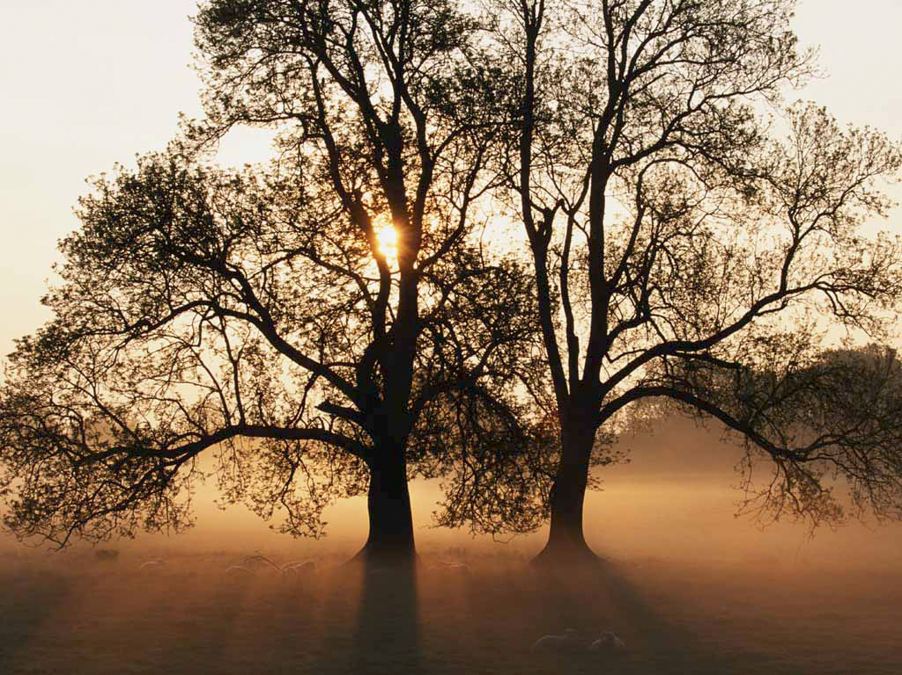
‘As grows a tree’
Session 1
‘Reflections’
Genesis 1:11
¹¹ ‘then God said, let the land produce vegetation: seed-bearing plants and trees on the land that bear fruit with seed in it, according to their various kinds. And it was so.’

Planted deep inside every born again believer is the Divine seed; the seed of a completely new DNA – we are, therefore, as Paul puts it ‘new creations’ in the Christ. The DNA implanted in us, is the very nature of Christ: side by side with this incorruptible seed, God has placed in each of us the desire to become like Jesus.

God is agricultural.

He doesn’t measure time, He measures - growth.

He placed the ‘seed’ of everything He made inside itself in order that it could reproduce after its kind...
Seeds...ummm
A seed floats gently down to the forest floor; it has all the possibilities within it of growing as majestic and stately as the tree from which it came...the little seed looks up, mature trees tower above it, and the tiny seed wonders how it could possibly become like them - so huge - their branches spread out giving shade to others, their roots go down deep into the soil, their fruit is evident...how did they get there it wonders...
It discovers a paradox – in order to live, it must die.
In order to grow like those around it, it must first suffer the pain of death by allowing its hard outer shell to break open and the tiniest of shoots to push out and then, into the ground. And, when its first little leaves appear it must reach both up and down – upward towards and light, downwards for nourishment.
It discovers that growing into a stately tree requires it to co-operate with the forces of nature, spring, summer, autumn, winter...
If it grows steadily and surely, producing a ring a year, it will mature into a mighty monarch of the forest like those around it...but there are no shortcuts, a ring a year; and there is no guarantee for this little seed, that it will come to maturity; it may be arrested at any stage; a seed, a sapling; coming up against an obstacle may cause it to arrest or bend at some point in its growth process...
God forbid it should go rotten in the ground...
A tree must undergo all kinds of tests in order to establish its root system and bear quality fruit. It must withstand the heat of summer; excessive cold and the frosts of winter; it must withstand strong winds; and survive in too much or too little water; all have their part to play in strengthening the growing plant causing it to put its roots down deep in order not to be blown over during a storm...
The cedar, for example, if it is to grow to an impressive height must be ever reaching upwards for more light; and it must allow the rain, wind and storms of life to strengthen it, not shrink from them...
It must grow far beyond the seedling or sapling stage, quietly making a ring each year as it grows in girth and height, reaching ever upwards towards the light...and downwards for nourishment; it simply has to make this growth if it is to produce the towering trunks from which timber will be cut...
Maybe it will prove excellent enough to produce timber for the Temple in Jerusalem...
During harsh winters trees are not picked up and moved to somewhere more sheltered, they have to go through the death process all over again; but when the winter is over, they will put forth their leaves - new life has been formed within them during that winter season of cold and loneliness...
Psalm 92:12 AMP
¹²The [uncompromisingly] righteous shall flourish like the palm tree [be long-lived, stately, upright, useful, and fruitful]; they shall grow like a cedar in Lebanon [majestic, stable, durable, and incorruptible]. ¹³Planted in the house of the Lord, they shall flourish in the courts of our God. ¹⁴[Growing in grace] they shall still bring forth fruit in old age; they shall be full of sap [of spiritual vitality] and [rich in the] verdure [of trust, love, and contentment].
King Solomon went to great lengths to obtain cedar from Lebanon, this was the very best timber available, for the Temple he built in Jerusalem – he had these great trees transported down to Jerusalem because there was no substitute for Cedar wood - it has a rich grain, it is lustrous and beautiful, it has a delicate aroma, a delightful fragrance, and it is durable and not subject to pests...
‘Full of spiritual vitality, durable, majestic, stable and incorruptible...’
Is it any wonder God likens our growth in fruitfulness to that of a tree?
Embracing all the seasons of our lives, processing the whole of life, disappointments and setbacks, betrayals and friendships, joy and pain with God is so important for our growth in order, like the tree, that we flourish and bring forth fruit - in due season.
How important it is, then, that we do not have an ‘escape’ mentality...‘Get me out of here, I'm a Christian’ – if we are to bear the fruit that lasts for eternity – the fruit of the Holy Spirit...
Each of us have this ‘good seed’ within but situations and circumstances arise that can cause us to stop growing or stunt our growth; it may be that we do not understand the reason for our trials and temptations; it may be a misunderstanding, a disappointment, resentment or rejection which cause us to stand still or give up; an offence causes us to twist and distort inside and make no more growth – people in church have hurt, disappointed and betrayed us and we use them as our yardstick for measuring what the Father is like - and give up on our walk...we are stunted, unable to bear a good and abundant crop, we bring forth fruit that is bitter not sweet, when we open our mouths...
But should we allow that death process to take place and the good seed to break open and take root in the soil of our hearts, it will bring forth precious fruit, 30, 60 or 100 fold, fruit that will last for eternity.
We need to ‘grow through’ and not just ‘go through’ all of life’s vicissitudes – its unexpected changes - the good times and the bad; summers and winters...
Knowing God, remembering that He is always with us and He is for us, He is in us and He wants us to succeed is a source of deep comfort on our dark winter days – drawing on the storehouse which we have built within us will sustain us.
So we needs must stockpile something in our hearts during the time of plenty, in the time of sunshine, warmth and water, in order that we will survive in the day of drought and famine...we must dig out our inner wells...so that in the time of drought we can still drink deeply...we must store that golden grain of His word and like Samuel, not let a word drop to the ground...
1 Samuel 3: 19 NIV
‘¹⁹The LORD was with Samuel as he grew up and he let none of His words fall to the ground.’
Like Joseph.
Storing up grain for the day when there was a famine in the land of Egypt...
Genesis 41:57 NIVUK
‘⁵⁷And all the countries came to Egypt to buy grain from Joseph, because the famine was severe in all the world.’
How’s your grain store right now?
Check it out, you never know when there is going to be a famine in the land of hearing the word of the Lord...
And, whatever the circumstances that surround your life you can choose to rejoice, because you need them - God has His programme for you and those circumstances will work for your profit; your ultimate good, whatever they are.
Hear Graham Cooke on the subject -
‘One of the most unpalatable truths that we may ever have to face is the fact that the choices we make and sometimes do not make have a very powerful impact on our life.’
Choices are always about power.
Failure to make the right choice or even not to exercise our options may give that power to someone or something else and leave us feeling weak and ineffective.
Choice is inescapable, so why not make it a joyful part of living?
What if choosing is one of the most important elements in our daily worship of God?
To come before the Creator who sees the end from the beginning...to live joyfully with the One who is so confident in His ability to choose that He can look all of His people in the eye and say, “I know the plans I have for you, plans for your welfare not your calamity, to give you a future and a hope.” (Jeremiah 29:11)
He loves to make choices, so why cannot we love it also? He is dedicated to making everything (in time) work together for our good, if we put Him first; love Him first...
Romans 8:28 AMP
‘²⁸ We are assured and know that [God being a partner in their labour] all things work together and are [fitting into a plan] for good to and for those who love God and are called according to [His] design and purpose.’
Only condition here – keep the first commandment first; love Him with all your heart, soul, mind and strength...it’s a choice, not a feeling...love, is a choice.
Choices always involve power and we must receive that power in the morning, afternoon and evening of each day. We live our lives today by virtue of the choices we made yesterday. Some decisions were easy; some difficult; others seemed almost to make themselves; whilst there were also choices that were so hard they made us pay a price up front that almost sucked the life out of us.
Choices can make or ruin our lives.
They have a very real substantive control over who we become and how we live.
Choices can put us in command of a situation or strip us of our authority to do well.
Choosing peace, trust, love, laughter, gentleness, calmness, joy, mercy and courage all take us into realms within ourselves that produce power.
The point of choice is where the image of Jesus in us first begins to become evident and real. The repercussions are powerful.
Choosing anger, fear, anxiety, bitterness and resentment take us backward or leave us stuck in ‘present past’, unable emotionally to overcome; this is the impact of choices we make or those made against us.
Sometimes we make choices to blame others when the reality is that we have handed over our power to them.
When we hand over the initiative in our own lives to another we abdicate control in our circumstances.
One of the fruit of the Spirit is self control.
Bringing our thoughts into a captive state before Jesus is the beginning of self-control.
Making calm, joyful, restful choices as a part of our normal intimate relationship with the Lord is the ongoing pursuit of self-control.
What if self-control is easier than we imagine? What if choices are less difficult than we suppose?
What if the challenge of God’s goodness is the place where all decisions can be made?
We are being made in His image. When we choose in fellowship with the Lord, He empowers those decisions and takes upon Himself the responsibility for fulfilment both in the situation and in the creation of His image within each of us.
Because of Christ within, we can choose wisely; we can also choose joyfully and calmly.
It is time we stopped giving our power away. God gave it to us; it is part of our fellowship with Him.
Each choice will result in your growth and fruitfulness and enable you to overcome, be victorious, in life – if you choose to let them. He is the Architect of your faith but you have to give Him building permission...
God is looking for us to produce; He’s looking for fruit in our lives, not from the old seed, but from the new, the good seed He implanted in us at our rebirth. The old seed will only bring forth death; the new, life and abundantly at that.
So somehow in all of this we have to learn to live from another seed, we have to learn to live in newness, not in the old way of human struggle with the Divine, but in the transforming power of the Holy Spirit - eating from the tree of Life, planted by streams of living water where our fruit production is guaranteed.
Fruit.
Someone has said that the fruit of Love and the fruit of Self-control are book-ends that hold the other fruit in place. Can’t disagree with that; whenever we speak of God, Love is the primary attribute we think of; trouble is we think that He loves in the same way as we do – then we discover that His love is unconditional – He loves those who hurt us, reject us, spurn us, speak despitefully about us, accuse and blame us...hey, wait a minute...that’s not what love is all about, love turns a blind eye to my faults and failings, it agrees with me when I get offended that I need vindication, and it’s always on my side, agreeing with my opinion...
That seed’s got to die...
Regeneration, transformation, that’s what it’s all about, the regenerating and transforming work of the Holy Spirit, the Minister of the Interior, who takes every situation in our lives and if we allow Him turns it to profit and ultimately, fruit – fragrant fruit, choice fruit that others may pick and enjoy...
Fruit.
All about fruit.
Many people are naturally kind and sympathetic, but that is no substitute for the fruit of the Spirit – the fruit of the Spirit is what it says it is, His; the Holy Spirit’s life being lived out through you. ‘Beloved, love one another’ – but it doesn’t take very long before we run out of our natural ability to bear and forebear with one another – the cracks soon show and ambition, rivalry, division and disharmony result; our ungoverned desires surface; everything that is not under the benevolent dictatorship of the Holy Spirit is exposed...
For some of us, the Song of Solomon may speak -
Song of Solomon 2:15 NIV
¹⁵ Catch for us the foxes, the little foxes that ruin the vineyards, our vineyards that are in bloom.
The vineyards are in bloom, the promise of fruit is there, but those little foxes will nip the shoots off that bear the blossom thus killing any hope of a harvest...little foxes, have you got any of those?

‘Little foxes’ – it’s not always the overt sins that trip us up, but the little ones, the things that we think God agrees with us about, our opinions of others, our judgements, our justifications of our own beliefs and behaviour, our angry outbursts and harsh tongue: and then there are the attitude sins that nibble away at the roots preventing or stunting fruit production - unforgiveness, bitterness, resentment, hatred, holding a grudge – are you holding a grudge or is a grudge holding you? Looking for vindication...a septic tank, festering, bubbling up, full of the bitterness of the past just ready to overflow out of our mouths...

‘You never...’

‘You always...’

Doing the work of the accuser...

Love keeps no record of wrong – really?

So have you got anything stored away there in your memory that festers, nibbles away at you, unforgiveness – Oh I’ve forgiven, but I can’t forget...beloved, if you can’t forget, you haven’t forgiven...if the memory still brings pain and the desire to retaliate...

Have you identified any ‘little foxes’?

Whenever we find ourselves accusing another, judging another, have you ever thought about it, we are doing the enemy’s work for him.

Take a moment do an inventory of your life – work with the Holy Spirit in this...
‘One of the most difficult things to preach about in church is death in the form of being crucified with Christ. It is a paradox that Christianity begins with closure. Death to self; repentance from dead works, reckon yourself dead to sin but alive to God, in Christ’.
So says Graham Cooke in his book ‘A Divine Confrontation’.
Have you had a Divine Confrontation? Are you having one right now perhaps?
Except a seed fall into the ground and die, it abides alone...death is followed by resurrection life.
The Vinedresser comes looking for fruit – I wonder what kind He will find on your vine?
Be blessed as you reflect on this, don’t be condemned, be convicted. Let the Holy Spirit work with you on the area He has just revealed to you – the area He wants to kiss next in order that you may bear fruit, 30, 60, 100 fold...
Fruit that will last – for eternity; you just get to choose how much you will bear...
30, 60, 100 fold...

Beryl M

There is currently no copyright on this material please feel free to copy it in its entirety.
Visit www.psalm131.com for more free downloads.
Thank you.

Oasis Community Trust is a Registered Charity Number 1029128.

